Martha Jane (Maddux) Parkison
October 28, 1845 – April 29, 1929

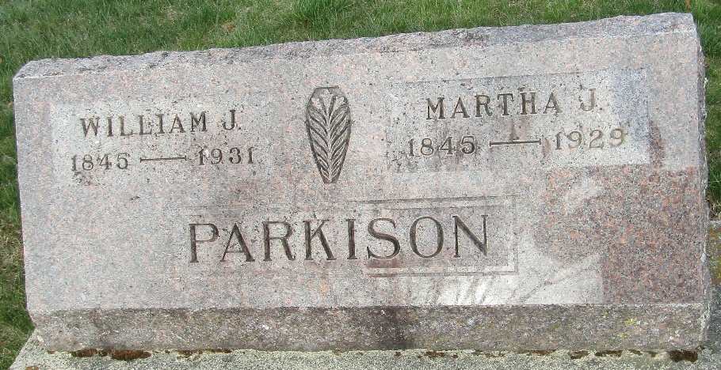

Martha Jane Parkinson
Indiana, U.S., Death Certificates, 1899-2017
Name Martha Jane Parkison
[Martha Jane Maddux]
Gender Female
Race White
Marital Status Married
Age 83
Birth Date 28 Oct 1845
Birth Place Wells County, Indiana
Death Date 29 Apr 1929
Death Place Bluffton, Wells, Indiana, USA
Death Registration Date 1929
Father Jacob Maddux
Mother Mary A Evans
Spouse Wm Parkison
Informant Wm. Parkison; Bluffton, Indiana
Burial May 1, 1929; Murray Cemetery

