Isabella Eunice (Johnston) Parkison
February 24, 1811 – June 26, 1886

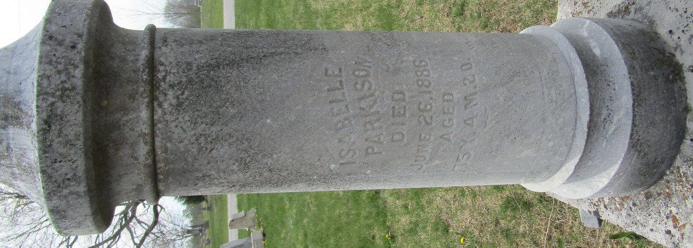

Isabella Eunice Johnston from tree Deborah Kay Parkison family tree
Birth 24 Feb 1811 Beaver City, Beaver, Pennsylvania, USA
Marriage 24 Sep 1840 Wayne, Monroe, Ohio, USA
Residence 1880 Wells, Indiana, USA
Death 26 Jun 1886 Wells, Indiana, USA
Father William Johnston (1782-1840)
Mother Margaret Davis (1793-1832)
Spouse Ebenezer Parkison (1813-1888)

