Ebenezer Parkison
June 13, 1813 – September 20, 1888

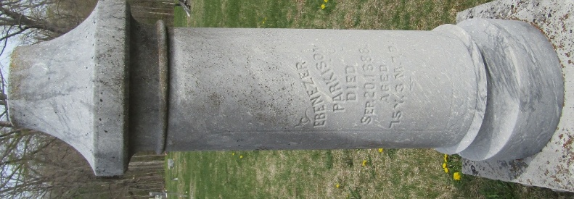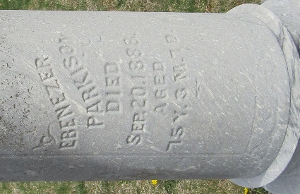

Kingsland
Mr. Ebenezer Parkison died last Thursday and was buried Saturday at the Murray Cemetery. The funeral was preached by Rev. Lawson in the church here. Mr. Parkison was past 75 years of age and was one of the pioneers of Wells County.
Bluffton Weekly Chronicle, Wells County, Indiana
September 27, 1888
**
Ebenezer Parkison from tree Deborah Kay Parkison family tree
Birth 13 Jun 1813 Jefferson, Ohio, USA
Marriage 24 Sep 1840 Wayne, Monroe, Ohio, USA
Residence 21 Apr 1884 Wells, Indiana, USA
Death 20 Sep 1888 Bluffton, Wells, Indiana, USA
Father Thomas Parkison (1782-1837)
Mother Eunice Coe (1783-1852)
Spouse Isabella Eunice Johnston (1811-1886)

