Charles Franklin Parkison
June 15, 1869 – September 23, 1899

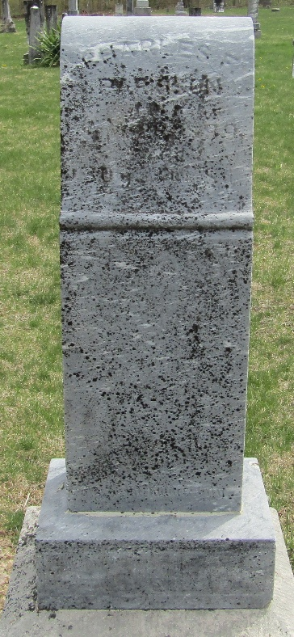

Mr. Charles Parkison, who lived one mile south of Kingsland, died
Saturday, September 23rd. After a serious attack of fever that lasted
for several weeks he was convalescent, but began to grow worse on
Thursday and continued becoming weaker until death came to relieve him. Even though he had been ill for several weeks his death came unexpected to his friends and relatives, who believed the most serious part of his sickness had passed.
As a young man he was always looked upon by his friends as one of
the most substantial and reliable members of the community, ever ready to lend his aid and influence toward anything that was for the good of the community.
During the days of his sickness when the delirium of the fever had
passed off he would inquire concerning his own Sabbath school class
which he taught with so much zeal and earnestness, and concerning the work of the church of which he was a faithful member. God, whose ways are mysterious to us, now has called him home and some day we'll understand why one so useful and in the vigor of manhood should have been called away so soon.
The funeral services were held at the Kingsland Presbyterian
church and his remains were interred in the Murray cemetery, his
pastor, Rev. Edward Campbell officiating.
Charles Franklin Parkison, son of William J. and Martha J.
Parkison, was born June 15th, 1869, and departed this life Sept. 23rd,
1899, aged 30 years 3 months and 8 days. He was married to Lela Hanna August 27th, 1895. United with the Presbyterian church in 1896, to which he has been a faithful and consistent member until death.
He leaves a wife, father, mother, three brothers and three sisters, also many friends and relatives to mourn their loss, which is his gain.

Unknown source

**
Charles Franklin Parkison from tree Weller Family Tree
Birth 15 Jun 1869 Wells, Indiana, USA
Residence 1870 Ossian, Wells, Indiana, USA
Marriage 27 Aug 1895 Wells, Indiana, USA
Death 23 Sep 1899 Wells, Indiana, USA
Father William J Parkison (1845-1931)
Mother Martha Jane Maddux (1845-1929)
Spouse Lela A. McAfee (1874-1961)

