Barbara Anna (Beery) Parkison
September 25, 1857 – March 13, 1888

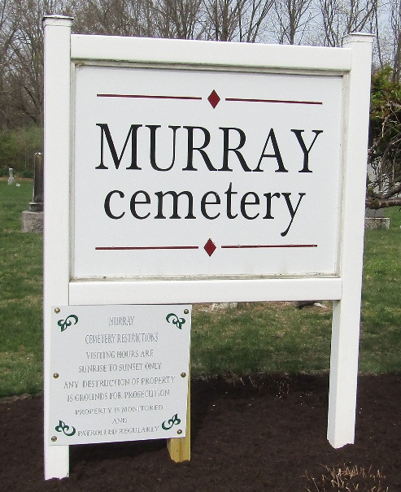

Barbara Anna Beery from tree Basil Henry Young Tree
Birth 25 Sep 1857 Celina, Mercer, Ohio, USA
Marriage 5 Oct 1876 Mercer, Ohio, USA
Residence 1880 Ossian, Wells, Indiana, USA
Death 13 Mar 1888 Hoagland, Allen, Indiana, USA
Father David Beery (1806-1881)
Mother Margaret Rebecca Engle (1811-1892)
Spouse Johnston Scott Parkison (1853-1943)

