Anna Pearl Parkison
March 7, 1888 – August 12, 1888

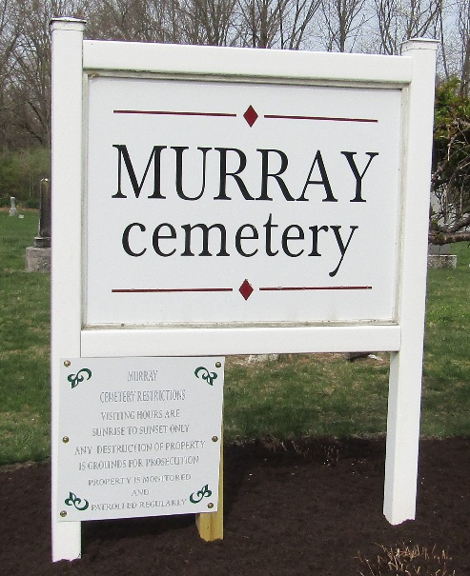

Anna Pearl Parkison from tree Giles-Beery-Cripe-Petcher Family Tree.
Birth 7 Mar 1888 Wells, Indiana, USA
Death 12 Aug 1888 USA
Father Johnston Scott Parkison (1853-1943)
Mother Barbara Anna Beery (1857-1888)

