Ann Jane (Riddle) Parkison
December 1, 1825 – September 11, 1900

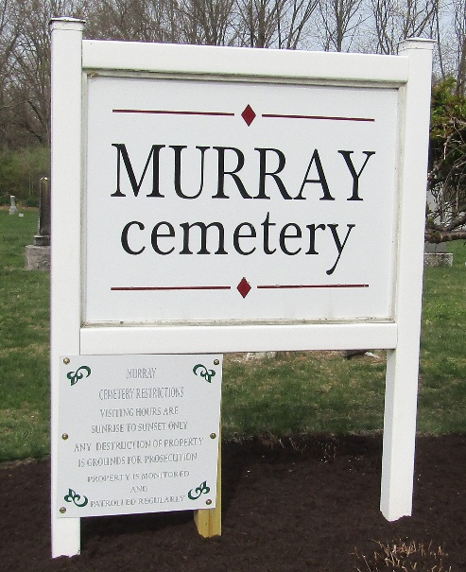

Ann James Parkison
Indiana, U.S., Death Certificates, 1899-2017
Name Ann Jane Parkison
[Ann Jane Riddle]
Gender Female
Race White
Marital Status Widowed
Age 74 years, 10 months, 20 days
Birth Date abt 1826
Birth Place Ohio
Death Date 11 Sep 1900
Death Place Bluffton, Wells, Indiana, USA
Death Registration Date 1899-1900
Father James Riddle
Mother Jane Bell
Informant Eunnus Lupton; Treaty, Indiana
Burial September 12, 1900; Murry Cemetery

**
Ann Jane Riddle from tree susan ellenberger family tree
Birth 1 Dec 1825 Pennsylvania, USA
Marriage 29 Jun 1848 Wells, Indiana, USA
Residence 1870 Wells, Indiana, USA
Death 11 Sep 1900 Bluffton, Wells, Indiana, USA
Father Janes Riddle
Mother Jane Riddle
Spouse Stephen Parkison (1821-1865)

