Sarah (Gailley) Parke
May 30, 1820 – March 30, 1891

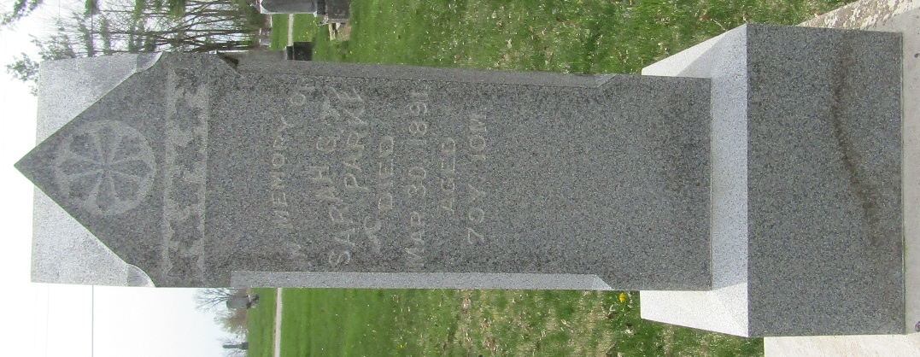

Sarah Gailey from tree Oakley-Boes-Park-Graham Family Tree
Birth 30 May 1820 Donegal, Ireland
Marriage 6 Jan 1842 Letterkenny, Donegal, Ireland
Residence 1880 Wells, Indiana, USA
Death 30 Mar 1891 Wells, Indiana, USA
Father Charles Gailey (Born 1768)
Mother Martha Gregg (Born 1770)
Spouse Henry Park (1812-1901)

