Henry Parke
January 16, 1812 – April 8, 1901

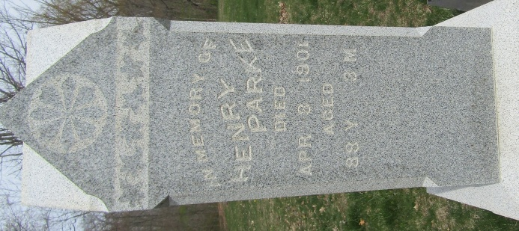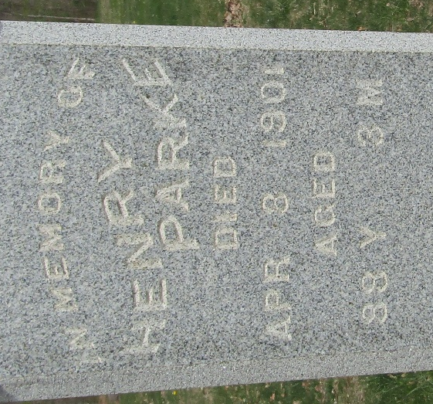

Henry Park
Indiana, U.S., Death Certificates, 1899-2017
Name Henry Park
Gender Male
Race White
Marital Status Widow
Age 88 years, 2 months, 27 days
Birth Date abt 1813
Birth Place Donegal Ireland
Death Date 8 Apr 1901
Death Place Lancaster, Wells, Indiana, USA
Death Registration Date 1901
Father Joseph Park
Mother Rebeca Torrens
Informant Herman Thomas; Bluffton, Indiana
Burial April 10, 1901; Murray Cemetery
**
Henry Park from tree Oakley-Boes-Park-Graham Family Tree
Birth 16 Jan 1812 Donegal, Donegal, Ireland
Marriage 6 Jan 1842 Letterkenny, Donegal, Ireland
Residence 1900 Wells, Indiana, USA
Death 8 Apr 1901 Wells, Indiana, USA
Father Joseph Park (1765-1851)
Mother Rebecca Torrens (1766-1852)
Spouse Sarah Gailey (1820-1891)

