Rachel Almira (Fulton) Park
August 3, 1850 – October 1, 1907

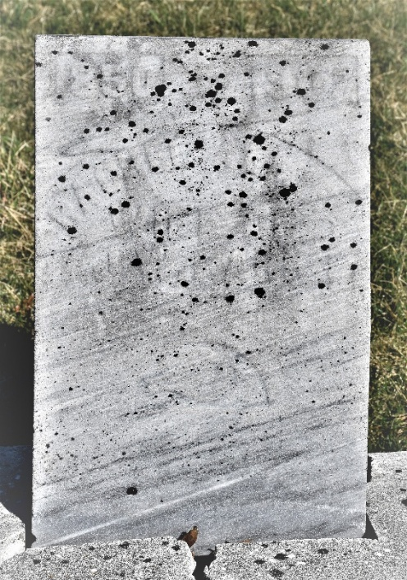

Rachel Almera Park
Indiana, U.S., Death Certificates, 1899-2017
Name Rachel Almera Park
[Rachel Almera Fulton]
Gender Female
Race White
Marital Status Married
Age 57
Birth Date 3 Aug 1850
Birth Place Wells County, Indiana
Death Date 1 Oct 1907
Death Place Murray, Wells, Indiana, USA
Death Registration Date 1907
Father John Fulton
Mother Sarah Egbert
Spouse Joseph W Park
Informant G. E. Fulton; Bluffton, Indiana
Burial October 3, 1907; Murray Cemetery

