Matthew Park
July 21, 1810 – April 21, 1894

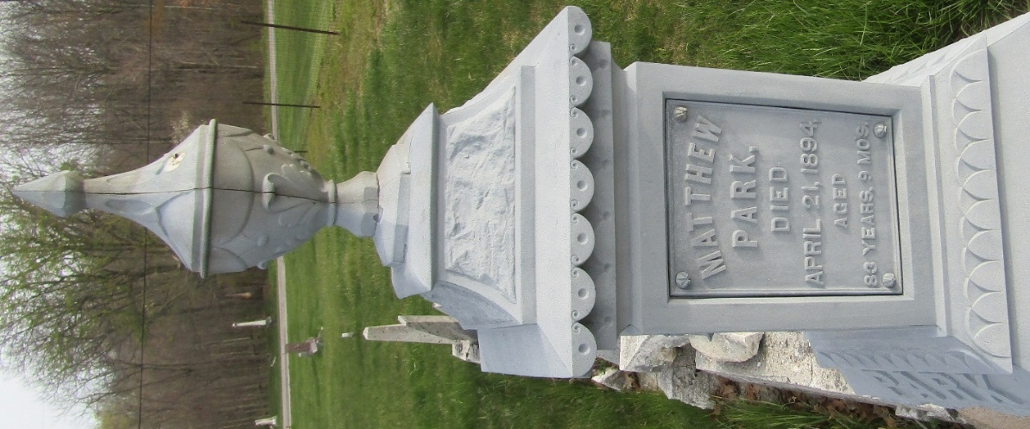

Matthew Park from tree jackie's Family's
Birth 25 Jul (OR 21 July) 1810 Donegal, Donegal, Ireland
Marriage 6 Jan 1842 Donegal, Donegal, Ireland
Residence 1880 Wells, Indiana, USA
Death 21 Apr 1894 Bartholomew, Indiana, USA
Father Joseph Park (1765-1851)
Mother Rebecca Torrens (1766-1852)
Spouse Jane Buchanan (1812-1904)

