Joseph William Park
April 22, 1847 – October 24, 1915

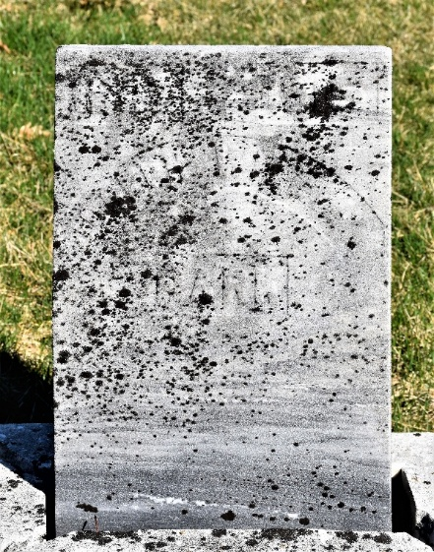

Joseph Wm Pork
Indiana, U.S., Death Certificates, 1899-2017
Name Joseph Wm Park
Gender Male
Race White
Marital Status Widowed
Age 68
Birth Date 22 Apr 1847
Birth Place Ireland
Death Date 24 Oct 1915
Death Place Murry, Wells, Indiana, USA
Death Registration Date 1910-1919
Father James Park
Mother Jane Buchanan
Spouse Rachel
Informant Robert Park; Murry, Indiana
Burial October 26, 1915; Murry Cemetery

