Jane (Buchanon) Park
May 30, 1812 – March 1, 1904

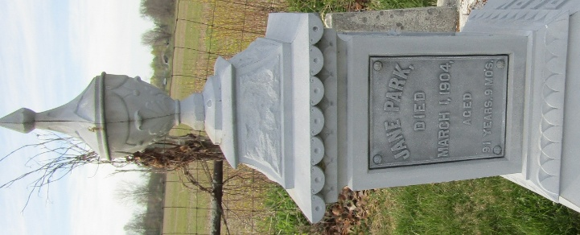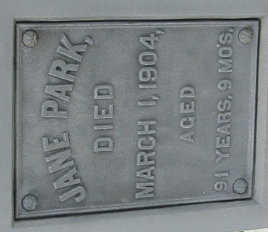

Jane Park
Indiana, U.S., Death Certificates, 1899-2017
Name Jane Park
[Jane Buchanon]
Gender Female
Race White
Marital Status Widowed
Age 91
Birth Date 30 May 1812
Birth Place Ireland Donegal County
Death Date 1 Mar 1904
Death Place Rock Creek, Wells, Indiana, USA
Death Registration Date 1904
Father Jess Buchanon
Mother Eleana Gregg
Spouse Mathew Park
Informant Mathew Park; Bluffton, Indiana
Burial March 3, 1904; Murray, Indiana

