Elias S. Pace
September 7, 1867 – March 14, 1939

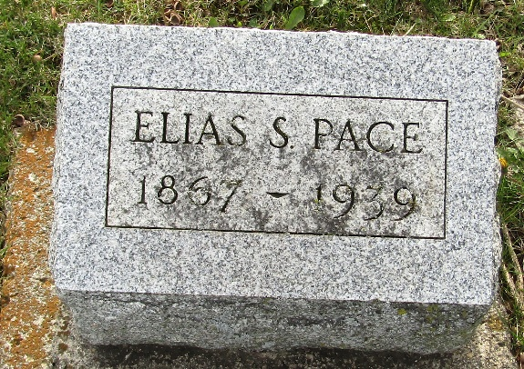

Elias S Pace
Indiana, U.S., Death Certificates, 1899-2017
Name Elias S Pace
Gender Male
Race White
Marital Status Married
Age 71
Birth Date 7 Sep 1867
Birth Place Indiana
Death Date 14 Mar 1939
Death Place Jefferson, Wells, Indiana, USA
Death Registration Date 1939
Father William Pace
Mother Judith Sutton
Spouse Ella Kirkendall
Informant Mrs. Ella Pace; Ossian, Indiana
Burial March 16, 1939; Murray Cemetery; Ossian, Indiana

