Earl Pace
April 9, 1886 – August 10, 1891

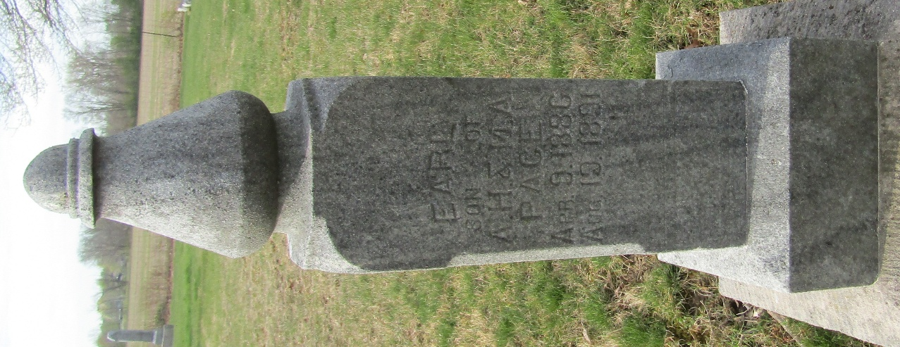

Earl Pace from tree Phillips Family Tree
Birth 9 Apr 1886
Death 10 Aug 1891
Father Alfred Hugh Pace (1852-1932)
Mother Melissa Jane Tanner (1864-1950)

