Charles Clinton Ormsby
July 4, 1872 – October 26, 1912

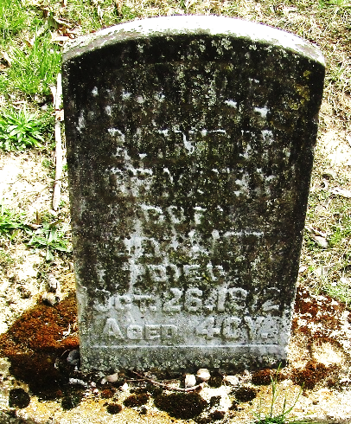

Charles Clinton Ormsby
Indiana, U.S., Death Certificates, 1899-2017
Name Charles Clinton Ormsby
Gender Male
Race White
Marital Status Married
Age 40
Birth Date 4 July 1872
Birth Place Paulding County, Ohio
Death Date 26 Oct 1912
Death Place Bluffton, Wells, Indiana, USA
Death Registration Date 1912
Father George Ormsby
Mother Mary Cathern Fryback
Spouse Carrie
Informant Mrs. C. C. Ormsby; Bluffton, Indiana
Burial October 1912; Murray Cemetery

