Phoebie Anna (Denman) Oman
April 6, 1869 – January 14, 1911

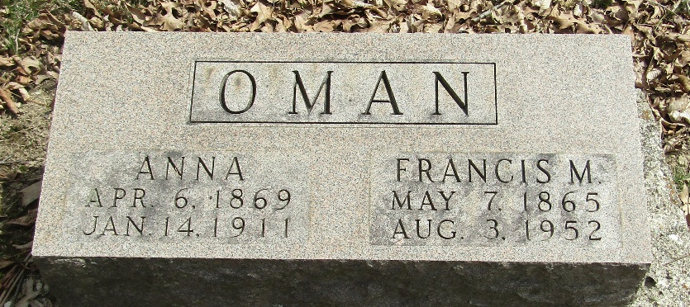

Pheobie Anna Oman
Indiana, U.S., Death Certificates, 1899-2017
Name Pheobie Anna Oman
[Pheobie Anna Denman]
Maiden Name Orman
Gender Female
Race White
Marital Status Married
Age 41
Birth Date 6 Apr 1869
Birth Place Adams County, Indiana
Death Date 14 Jan 1911
Death Place Salamonia, Wells, Indiana, USA
Death Registration Date 1911
Father Samuel Denman
Mother Susan
Spouse Frank Oman
Informant Frank Oman; Bluffton, Indiana
Burial January 16, 1911; Murray Cemetery

