Francis M. Oman
May 7, 1865 – August 3, 1952

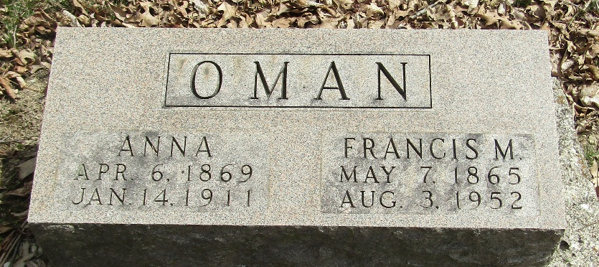

Frank M. Oman Is Claimed by Death

Frank M. Oman, 87, Murray, died at 1 p.m. Sunday at the Wells County Hospital, where he had been a patient since last Monday. Death was attributed to infirmities of age.
He was born in Wells County on May 7, 1865, a son of William and Mary Conner Oman. His marriage in 1891 was to Phoebe Ann Denman, whose death occurred Jan. 14, 1911.
A lifelong resident of the county, the decedent was a member of the Murray Christian Church.
Surviving are two sons, Harry Ray of Allegan, Mich., and Floyd K. of Chicago. Six brother, William, Henry, Ed, Albert, John and Noah Oman, and three sisters, Mrs. Cora Hooker, Mrs. Jane Melchi and Mary Oman, are deceased
The body was taken to the Thoma Funeral Home, where friends may call after 4:30 this evening. Funeral services will be held at 2 p.m. Tuesday at the Murray Christian Church with Rev. Louis Klotzbach officiating. Burial will be in Murray Cemetery.

Bluffton New Banner, Wells County, Indiana
Monday, August 4, 1952, p. 1, c. 2

**
Indiana, U.S., Death Certificates, 1899-2017
Name Frank M Oman
Gender Male; Race White
Marital Status Widowed
Age 87
Birth Date 7 May 1865; Birth Place Indiana
Death Date 3 Aug 1952; Death Place Bluffton, Wells, Indiana, USA
Father William Oman
Mother Mary Conner
Informant Harry Ray Oman; Allegan, Michigan
Burial August 5, 1952; Murray, Indiana

