Cecil B. Oman
1894 - 1895

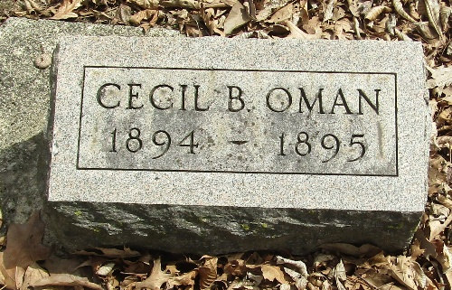

Cecil B Oman from tree Rosemary Leaves
Birth 1894 Wells, Indiana, USA
Death 1895 Wells, Indiana, USA
Father Francis "Frank" Marion Oman (1865-1952)
Mother Phoebe Anna Denman (1869-1911)

