Violet May Oliver
September 2, 1914 – May 9, 1931

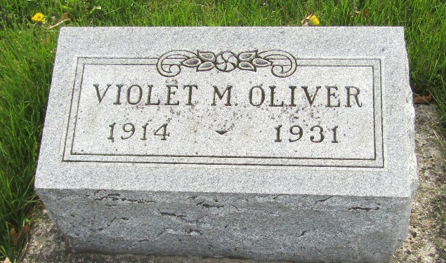

Violet May Oliver
Indiana, U.S., Death Certificates, 1899-2017
Name Violet May Oliver
Race F
Marital Status Single
Age 16
Birth Date 2 Sep 1914
Birth Place Indiana
Death Date 9 May 1931
Death Place Jefferson, Wells, Indiana, USA
Death Registration Date 1931
Father Andrew Oliver
Mother Meda Hoopengardner
Informant Andrew Oliver; Ossian, Indiana
Burial May 11, 1931; Murray Cemetery

