Patience Ruth (Vick) Oliver
January 27, 1842 – June 10, 1912

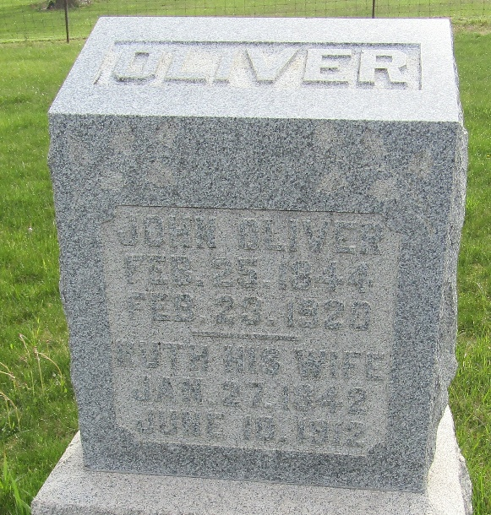

Patience R. Oliver
Indiana, U.S., Death Certificates, 1899-2017
Name Patience R. Oliver
[Patience R. Vick]
Gender Female
Race White
Marital Status Married
Age 70
Birth Date 27 Jan 1842
Birth Place Virginia
Death Date 10 Jun 1912
Death Place Jefferson, Wells, Indiana, USA
Death Registration Date 1912
Father Willis Vick
Mother Martha Hargrove
Spouse John Oliver
Informant John Oliver; Kingsland, Indiana
Burial June 12, 1912; Murray Cemetery

