Meda J. (Hoopengardner) Oliver
November 23, 1873 – August 16, 1955

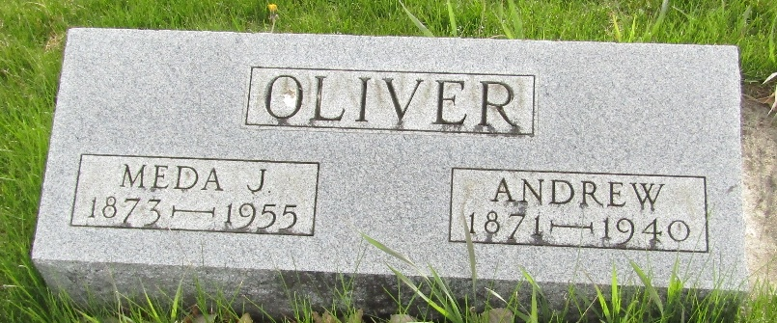

Meda J Oister
Indiana, U.S., Death Certificates, 1899-2017
Name Meda J Oliver
[Meda Hoopengardner]
Gender Female
Race White
Marital Status Widowed
Age 82
Birth Date 23 Nov 1872 (sic)
Birth Place Wells County, Indiana
Death Date 16 Aug 1955
Death Place Fort Wayne, Allen, Indiana, USA
Death Registration Date 1955
Father David Hoopengardner
Mother Ady
Informant Mrs. Howard Talbott; Waynedale, Indiana
Burial August 18, 1955; Murray Cemetery; Murray, Indiana

