Lottie B. (McCarty) Oliver
April 15, 1897 – June 16, 1947

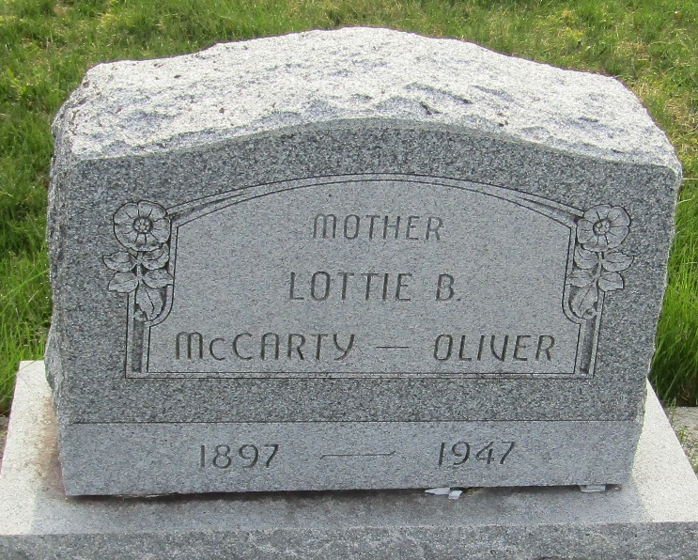

Lottie B Oliver
Indiana, U.S., Death Certificates, 1899-2017
Name Lottie B Oliver
Gender Female
Race White
Marital Status Married
Age 50
[50]
Birth Date 15 Apr 1897
Birth Place Clinton County, Indiana
Death Date 16 Jun 1947
Death Place Indianapolis, Marion, Indiana, USA
Death Registration Date 1947
Father James O Mc Carty
Mother Rosie V Lydy
Spouse Jesse; age 52
Informant Walter Oliver
Burial June 19, 1947; Murray Cemetery; Murray, Indiana

