John W. Oliver
February 25, 1844 – February 24, 1920

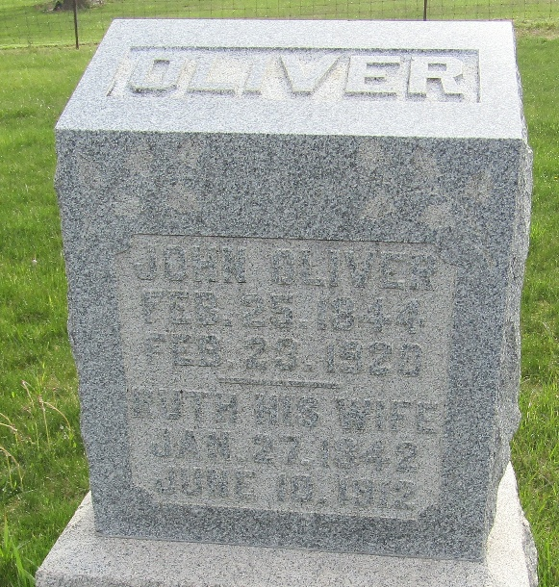

John W. Oliver
Indiana, U.S., Death Certificates, 1899-2017
Name John W. Oliver
Gender Male
Race White
Marital Status Widowed
Age 75
Birth Date 25 Feb 1844
Birth Place Indiana
Death Date 24 Feb 1920
Death Place Fort Wayne, Allen, Indiana, USA
Death Registration Date 1920
Father William Oliver
Mother Patiense Vick
Spouse Mary
Informant William Kellar; Fort Wayne, Indiana
Burial February 26, 1920; Murray Cemetery

