James Walter Oliver
July 31, 1914 – March 14, 1954

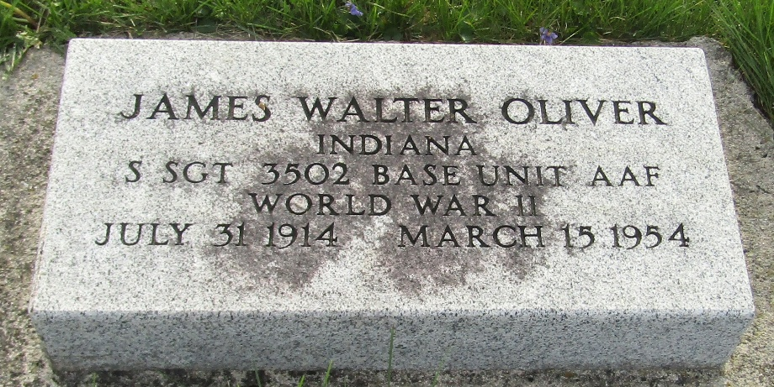

Walter Oliver, age 39, who resided at 155 1/2 West Main street, Gas City, passed away at the Marion General Hospital at 6:30 p.m. Sunday after he was found eight and one-half hours earlier in his car parked along the Muncie Pike. Cause of death is undetermined.
Born in Bluffton, Mr. Oliver lived in Gas City most of his life and was employed at Knox Glass Company. He was a veteran of WWII and a member of the Gas City V. F. W.
Surviving are his wife, Ruby; his father Jesse, Gas City; a brother, John, and a sister, Mattie Pearson, both of Downey, California.
Funeral services will be held Thursday afternoon at 2 o'clock at the Jay and Swift Home, with Rev. Dewey Hole in charge. Burial will be in Murray, Indiana. The Gas City V. F. W. will be in charge of military services and furnish pallbearers.
The Journal Newspaper, Grant County, Indiana
Wednesday, March 17, 1954
**
Indiana, U.S., Death Certificates, 1899-2017
Name James Walter Oliver
Gender Male
Race White
Marital Status Married
Veteran World War II
Age 39
Birth Date 31 Jul 1914
Birth Place Indiana
Death Date 14 Mar 1954
Death Place Marion, Grant, Indiana, USA
Father Jesse Oliver
Mother Lottie McCarty
Informant Ruby Oliver; Gas City, Indiana
Burial March 18, 1954; Murray Cemetery; Wells County, Indiana

