Clara Ella (Turner) Oliver
July 21, 1878 – April 4, 1959

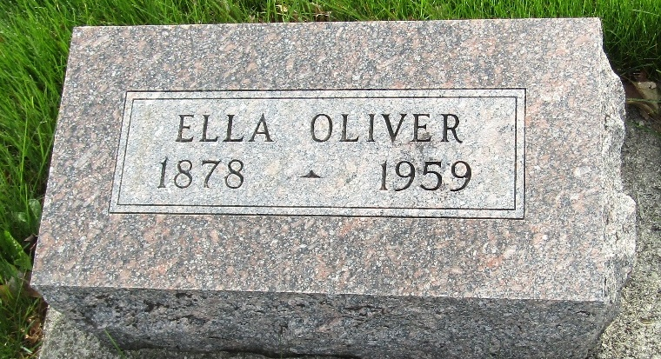

Clara Ella Oliver
Indiana, U.S., Death Certificates, 1899-2017
Name Clara Ella Oliver
[Clara Ella Turner]
Gender Female
Race White
Marital Status Widowed
Age 80
Birth Date 21 Jul 1878
Birth Place Warren, Indiana
Death Date 4 Apr 1959
Death Place Fort Wayne, Allen, Indiana, USA
Death Registration Date 1959
Father Louise Turner
Mother Maldia Crandell
Informant Miss Rosa Turner; sister; Fort Wayne, Indiana
Burial April 7, 1959; Murray Cemetery; Wells County, Indiana

