Andrew Oliver
June 6, 1871 – March 10, 1940

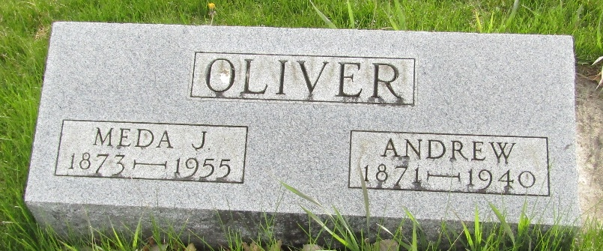

ANDREW OLIVER DIES EAST OF UNIONDALE
DEATH OCCURS SUNDAY EVENING AND FUNERAL WILL BE HELD TUESDAY

Andrew Oliver, 68, retired farmer, died at 7:30 p.m. Sunday at his home two miles east of Uniondale, after an illness of two weeks from a paralytic stroke.
The decedent was born June 6, 1871, in Blackford County, a son of John W. and Ruth Vick Oliver. His marriage was to Almeda Hoopengardner.
Surviving is the widow, Mrs. Almeda Oliver; one daughter, Mrs. Howard Talbott, of Waynedale; three grandchildren; one brother, Oscar Oliver, of Kansas City, Mo., and one sister, Mrs. Walter Keller, of Fort Wayne.
The decedent was a member of the Uniondale Methodist Church.
The body is at the Elzy & Son Funeral Home at Ossian. Funeral services will be held Wednesday at 2 p.m. at the residence with burial at Murray.

Evening News Banner, Wells County, Indiana,
Monday, March 11, 1940

**
Indiana, U.S., Death Certificates, 1899-2017
Name Andrew Oliver
Gender Male; Race White
Marital Status Married
Age 68
Birth Date 6 Jun 1871
Birth Place Blackford County, Indiana
Death Date 10 Mar 1940
Death Place Rural, Wells, Indiana, USA
Father John W Oliver
Mother Ruth Vick
Spouse Almeda
Informant Mrs. Almeda Oliver; Ossian, Indiana
Burial March 13, 1940; Murray Cemetery; Murray, Indiana

