Bertha Pearl Ogden
October 20, 1875 – February 9, 1897

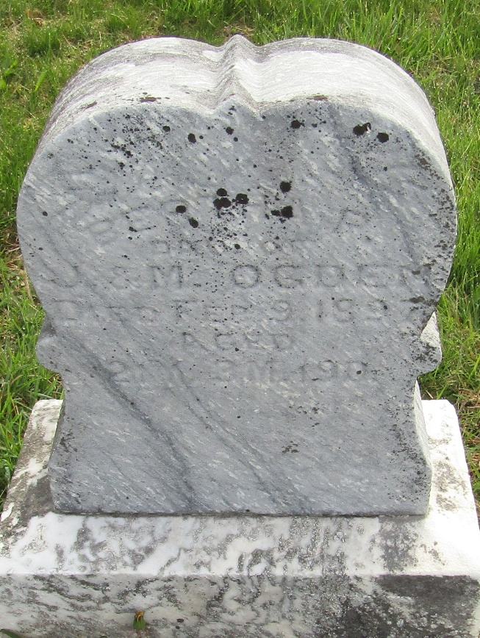

Bertha Pearl Ogden from tree Guede1
Birth 20 Oct 1875
Residence 1880 Dunreith, Henry, Indiana, USA
Death 9 Feb 1897
Father James Sherry Ogden (1839-1920)
Mother Mary A. Cubberly (1843-1925)

