Maria G. (Bulger) Nosset
April 15, 1809 – May 8, 1874

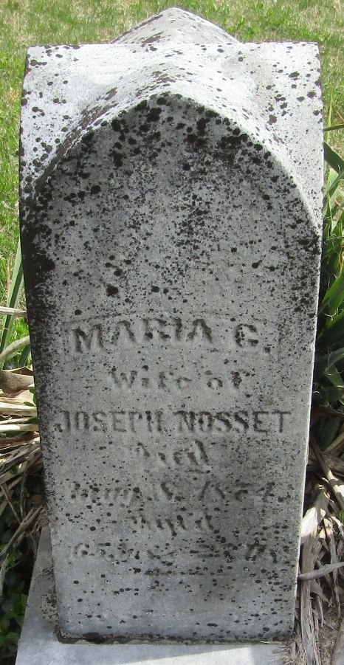
Photo by JC

No further information found at this time

