Allen Norcross
May 5, 1802 – June 16, 1879

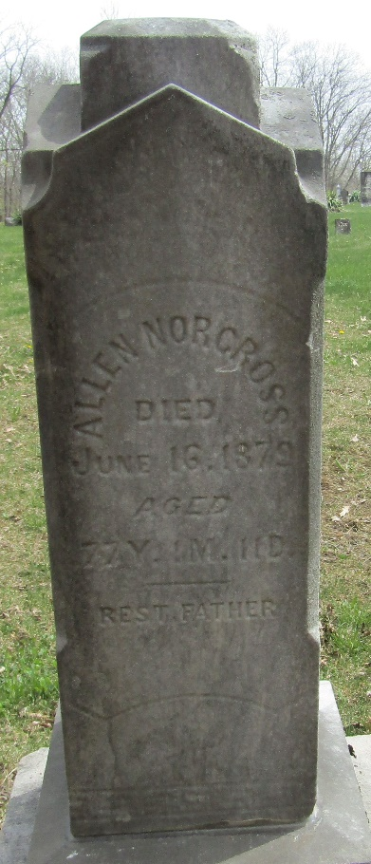
Photo by JC
Allen Norcross from tree di's hilyard Family Tree
Birth 5 May 1802 Monmouth, New Jersey, USA
Marriage 2 Dec 1841 Vanderburgh, Indiana, USA
Residence 1870 Wells, Indiana, USA
Death 16 Jun 1879 Bluffton, Wells, Indiana, USA
Father John A. Norcross (1763-1855)
Mother Lydia Hilyard (1764-1864)
Spouse Eleanor Vannatta (1807-1872)
Spouse Jane Sangford

