Jackie Neal Niblick
March 29, 1932 – March 29, 1932

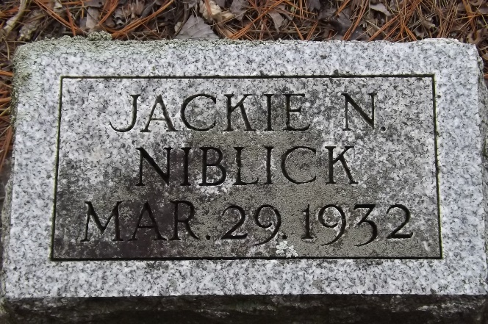
Photo by Jim Allen

Jackie Neal Niblick from tree Gamble Family Tree
Birth 29 Mar 1932 Bluffton, Wells, Indiana, USA
Death 29 Mar 1932 Bluffton, Wells, Indiana, USA
Father Robert M. Niblick (1913-1984)
Mother Lena Pauline Harris (1913-2001)

