Milo Nelson
January 16, 1850 – December 8, 1923

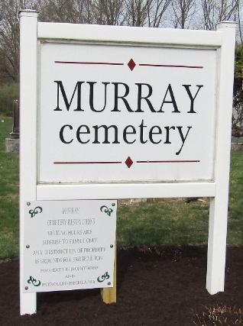
Photo by JC

Milo Nelson
Indiana, U.S., Death Certificates, 1899-2017
Name Milo Nelson
Gender Male
Race White
Marital Status Widower
Age 73
Birth Date 16 Jan 1850
Birth Place Indiana
Death Date 8 Dec 1923
Death Place Kingsland, Wells, Indiana, USA
Death Registration Date 1923
Father James Nelson
Mother Sarah Beals
Spouse Mary A.
Informant Mrs. Dessie Hunt; Ossian, Indiana
Burial December 10, 1923; Murray Cemetery

