Lilie D. Nelson

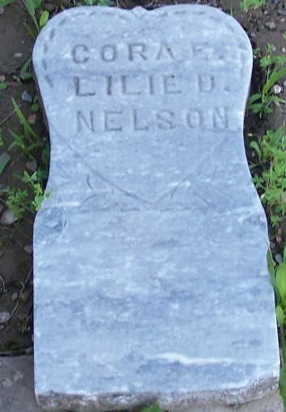
Photo by Barb

No further information found at this time

