James Nelson
March 14, 1813 – August 22, 1886

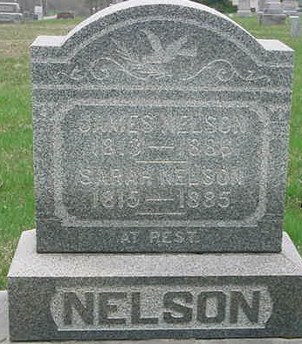
Photo by Smalltown

James Nelson was born March 14, 1813, in York County, Pennsylvania. When he was twelve years old, he moved with his parents to Wayne County, Ohio. He was married to Sarah Beals, October 17, 1833. He lived about three years in Stark County, Ohio from which place he moved to Adams County, Indiana, in September, 1844. In February 1849, he moved to Wells County, where he settled on a farm in Lancaster Township, where he lived until his death, Sunday August 22, 1886, aged 73 years, 5 months, and 8 days.
His funeral, together with that of his wife, who died February 19, 1885, was preached by Rev. Lewellyn of the Ossian M. E. Church, at the residence. He was buried in the Murray Graveyard.
He leaves to mourn his death, eight children, twenty-seven grandchildren and four great-grandchildren, besides many friends.

Bluffton Banner, Wells County, Indiana
September 2, 1886
**
James NELSON from tree Lieb Family Tree
Birth 14 Mar 1813 York, Pennsylvania, USA
Marriage 17 Oct 1833 Wayne, Monroe, Ohio, USA
Residence 1880 Wells, Indiana, USA
Death 22 Aug 1886 Wells, Indiana, USA.
Father William Nelson (1784-1860)
Mother Barbara Schweissguth* (1794-1837)
Spouse Sarah BEALS (1815-1885)

