Cora E. Nelson
1874 -

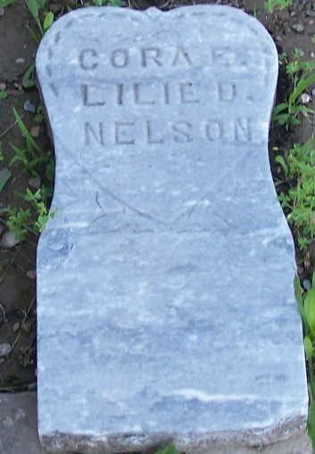
Photo by Barb

Cora Nelson b. 1874 (from ancestry tree of her fathers; in 1880 census)

Cora E. Nelson from tree Durham Family Tree
Birth 1874 Indiana, USA
Residence 1880 Wells, Indiana, USA
Father Milo Nelson (1850-1923)
Mother Mary Allie Johnson (1855-1898)

