Mariah (Jones) Nash
November 3, 1805 – November 3, 1860

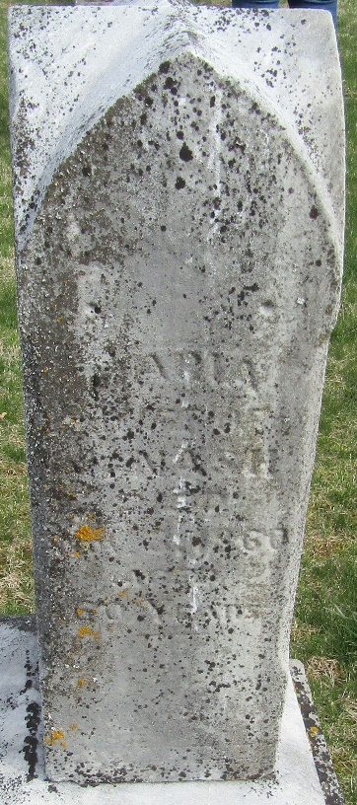
Photo by JC

Mariah Jones from tree Budden - Pealer 2014
Birth 3 Nov 1805 Marion, Smyth, Virginia, USA
Marriage 19 Sep 1825 Jefferson, Ashtabula, Ohio, USA
Residence 1860 Bluffton, Wells, Indiana, USA
Death 3 Nov 1860 Wells, Indiana, USA
Father Flemming Jones (1761-1806)
Mother Christiana Kerns (1770-1840)
Spouse John Nash (1796-1871)

