Margaret (Shady) Nash
August 16, 1835 – March 4, 1882

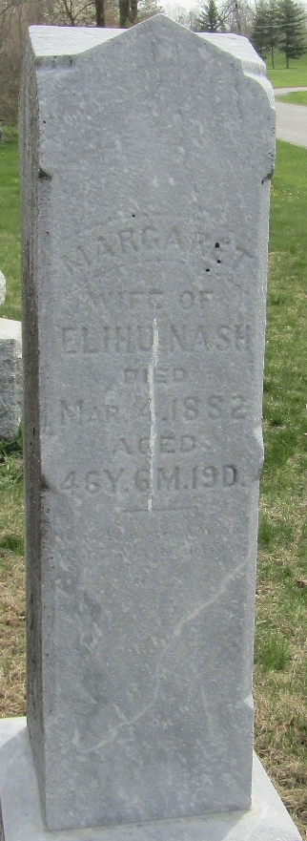
Photo by JC

Margaret Shady from tree Sander Wilson Family Tree
Birth 16 Aug 1835 Fairfield, Ohio, USA
Marriage 31 Jan 1858 Allen, Indiana, USA
Residence 1880 Wells, Indiana, USA
Death 4 Mar 1882 Adams, Indiana, USA
Father William Shady (1804-1879)
Mother Susannah Grim (1802-1876)
Spouse Elihu Nash (1833-1902)

