Lydia (Hamlin) Nash
July 12, 1799 – March 8, 1853

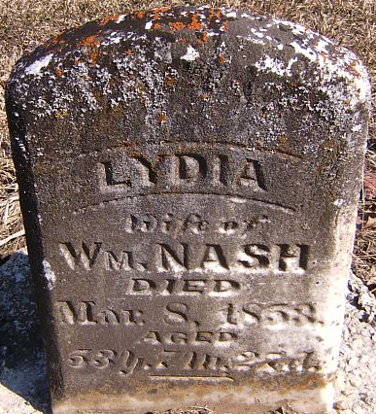
Photo by Patrick

Lydia Hamlin from tree Hamlin Family
Birth 12 Jul 1799 Surry, Surry, Virginia, USA
Marriage 3 Jan 1826 Stark, Ohio, USA
Residence 1850 Wells, Indiana, USA
Death 8 Mar 1853 Wells, Indiana, USA
Father John D * Hamlin (1763-1836)
Mother Elizabeth * Johnson (1775-1840)
Spouse William Nash (1805-1856)

