Levi Nash
May 20, 1844 – April 19, 1910

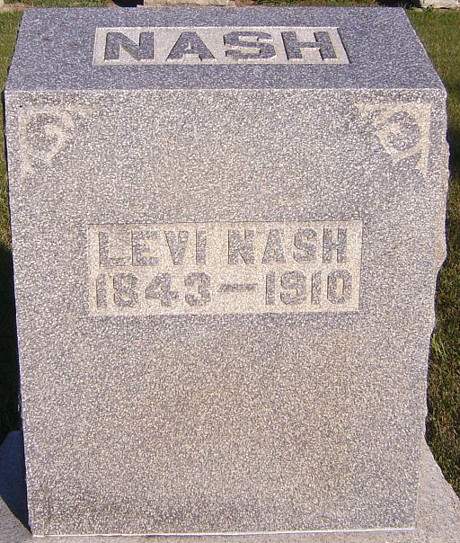
Photo by Patrick

DEATH CAUSED BY BRIGHT’S DISEASE
LEVI NASH DIED WEDNESDAY AT THE HOME OF MR. AND MRS. JOHN WIBEL
Levi Nash, an aged bachelor, who had made his home for some time with his niece, Mrs. John Wibel, two miles north of Craigville, passed away at 10:30 o’clock Wednesday forenoon after having been in a comatose state for four days. Mr. Nash had been a sufferer from Bright’s disease and had been in feeble health for several weeks. Last Friday night, Mrs. Wibel heard him fall in his bedroom and she and her husband investigated, and found him lying on the floor helpless. He sank into unconsciousness as they placed him in the bed, and he rallied only slightly at intervals from that time until his death.
The decedent was an uncle of William J. Nash of this city, and the late Elihu Nash was a brother. He leaves many relatives in the northeast part of the county, and a number of others in this city, besides the nephew mentioned above.
The funeral was held Friday at ten o’clock at the Lancaster Chapel Church.

Unknown source

**
Levi Nash
Indiana, U.S., Death Certificates, 1899-2017
Name Levi Nash
Gender Male
Race White
Marital Status Single
Age 65
Birth Date 20 May 1844
Birth Place Indiana
Death Date 19 Apr 1910
Death Place Lancaster, Wells, Indiana, USA
Death Registration Date 1910
Father Nash
Mother Unknown
Informant John Wifel; Craigville, Indiana
Burial April 22, 1910; Murray Cemetery
**
Levi Nash from tree Hamlin Family
Birth 20 May 1844 Wells, Indiana, USA
Residence 1880 Wells, Indiana, USA
Death 19 Apr 1910 Craigville, Wells, Indiana, USA
Father William Nash (1805-1856)
Mother Lydia Hamlin (1799-1853)

