Joseph M. Nash
February 25, 1859 - 1879

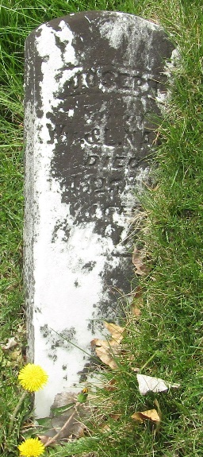
Photo by JC

Joseph M. Nash from tree Fiedler/Cryer
Birth 25 Feb 1859 Wells, Indiana, USA
Residence 1860 Bluffton, Wells, Indiana, USA
Death 1879 Wells, Indiana, USA
Father Elihu M Nash (1833-1902)
Mother Margaret Shady (1835-1882)

