John Nash
December 8, 1796 – March 28, 1871

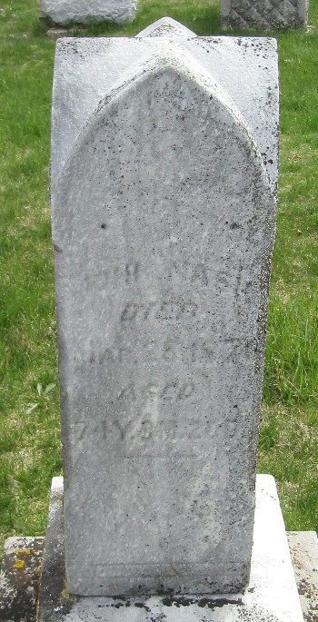
Photo by JC

John Nash from tree Budden - Pealer 2014
Birth 8 Dec 1796 Cecil, Maryland, USA
Marriage 19 Sep 1825 Jefferson, Ashtabula, Ohio, USA
Residence 1870 Wells, Indiana, USA
Death 28 Mar 1871 Wells, Indiana, USA
Father Stephen Nash (1769-1846)
Mother Mary McBride (1771-1851)
Spouse Mariah Jones (1805-1860)

