Eliza J. (Wasson) Nash
January 4, 1836 – October 6, 1913

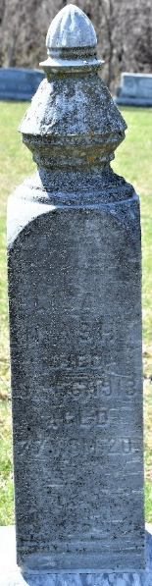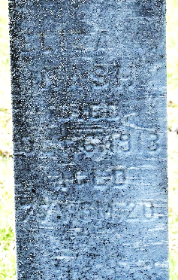
Photo by Colleen Sanders
Eliza J. Nash
Indiana, U.S., Death Certificates, 1899-2017
Name Eliza J. Nash
[Eliza J. Wasson]
Gender Female
Race White
Marital Status Widowed
Age 77
Birth Date 4 Jan 1836
Birth Place Wayne County, Ohio
Death Date 6 Oct 1913
Death Place Union Twp., Wells Co., Indiana, USA
Death Registration Date 1913
Father George Wasson
Mother Ash
Informant Emma Brickley; Uniondale, Indiana
Burial October 8, 1913; Murray Cemetery

