Elihu Nash
January 27, 1833 – November 30, 1902

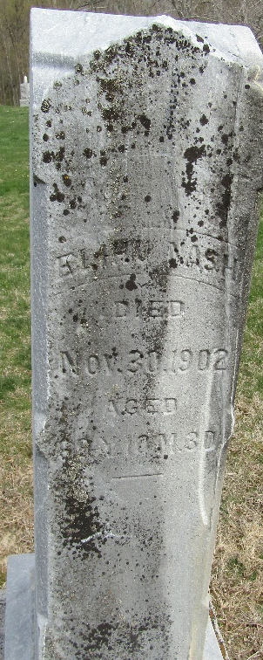
Photo by JC

Elihue Nosh
Indiana, U.S., Death Certificates, 1899-2017
Name Elihue Nash
Gender Male
Race White
Marital Status Widower
Age 69
Birth Date 27 Jan 1833
Birth Place Ohio
Death Date 30 Nov 1902
Death Place Wells, Indiana, USA
Death Registration Date 1902
Father Wm Nash
Mother Unknown
Spouse Jemima
Informant William Nash
Burial December 2, 1902; Murray Cemetery
**
Elihu M. NASH from tree Stewart Family Tree
Birth 27 Jan 1833 Marlboro, Stark, Ohio, USA
Marriage 31 Jan 1858 Allen, Indiana, USA
Residence 1900 Wells, Indiana, USA
Death 30 Nov 1902 Wells, Indiana, USA
Father William NASH (1805-1856)
Mother Lydia HAMLIN (1800-1853)
Spouse Margaret Shady (1835-1882)
Spouse Jemima Shock

