William O. Myers
March 2, 1878 – September 26, 1952

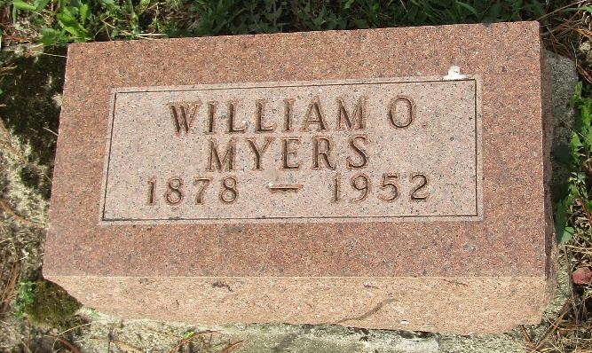

William Myers
Indiana, U.S., Death Certificates, 1899-2017
Name William Myers
Gender Male
Race White
Marital Status Widowed
Age 74
Birth Date 2 Mar 1878
Birth Place Indiana
Death Date 26 Sep 1952; suicide by gunshot
Death Place Bluffton, Wells, Indiana, USA
Death Registration Date 1952
Father Asa Myers
Mother Caroline Robinson
Informant Jahn S.; Undertaker; Bluffton, Indiana
Burial September 28, 1952; Murray Cemetery; Bluffton, Indiana

