Sarah Drusilla Myers
March 9, 1851 – February 19, 1853

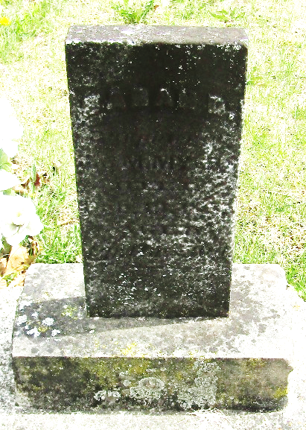

Sarah Drusilla Myers from tree DeBolt/Shiley
Birth 9 Mar 1851 Wells, Indiana, USA
Death 19 Feb 1853 Wells, Indiana, USA
Father Jacob Myers (1813-1899)
Mother Martha DeHaven (1815-1906)

