Orlin J. Myers
July 20, 1840 – August 6, 1925

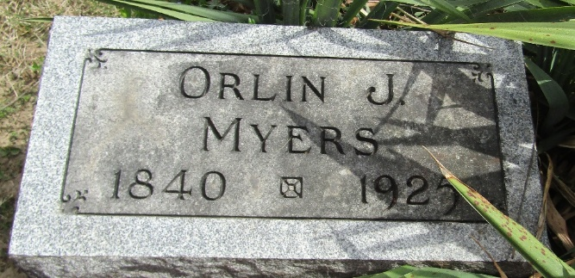

Orlan J. Meyers
Indiana, U.S., Death Certificates, 1899-2017
Name Orlan J. Meyers
Gender Male
Race White
Marital Status Married
Age 85
Birth Date 20 Jul 1840
Birth Place Ohio
Death Date 6 Aug 1925
Death Place Lancaster, Wells, Indiana, USA
Death Registration Date 1925
Father Jacob Myers
Mother Martha Dehaven
Spouse Christiana
Informant Christiana Myers; Bluffton, Indiana
Burial August 8, 1925; Murray Cemetery

