Martha M. (DeHaven) Myers
December 8, 1815 – June 9, 1906

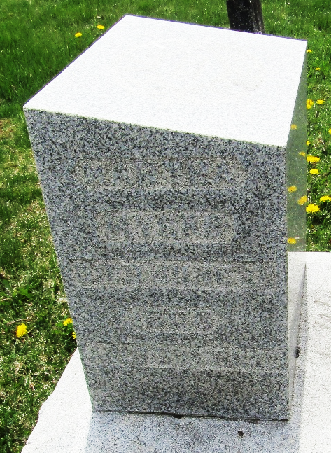

Martha M Yen
Indiana, U.S., Death Certificates, 1899-2017
Name Martha M Myers
[Martha M DeHaven]
Gender Female; Race White
Marital Status Widow
Age 92
Birth Date 8 Dec 1815, Birth Place Springfield, Ohio
Death Date 9 Jun 1906, Death Place Murray, Wells, Indiana, USA
Father Nathaniel C DeHaven
Mother Dois Baldwin
Spouse Jacob Myers
Informant Joseph Myers; Bluffton, Indiana
Burial June 11, 1906; Murray Cemetery

