Martha J. (Black) Myers
May 13, 1849 - November 11, 1894

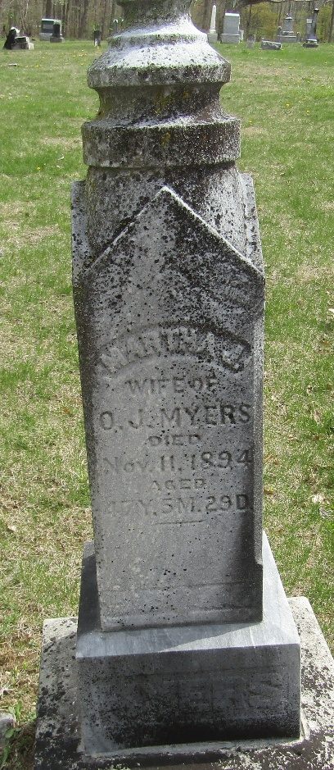

Indiana, U.S., WPA Death Index, 1882-1920
Name Martha J. Myers
Date Nov 11, 1894
Location Wells County
Age 47 Yr
Gender Female
Race White
Source location County Health Office, Bluffton
Source notes The source of this record is the book H-14 on page 88 within the series produced by the Indiana Works Progress Administration.

**
Indiana, U.S., Marriages, 1810-2001
Name Martha J Black
Gender Female
Event Type Marriage Registration (Marriage)
Marriage Date 29 Sep 1869
Marriage Place Indiana, United States
Spouse Oslin J Myers
Page 52
FHL Film Number 002318462

