Maggie E. Myers
1873 - 1873

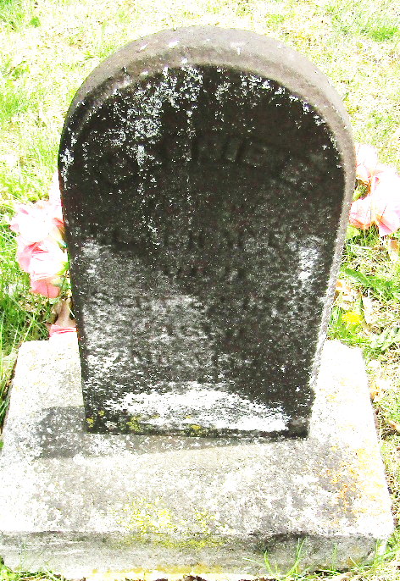

Maggie E Myers from tree Veits
Birth Feb 1873
Death Sep 1873
Father Joseph Lee Myers (1838-1928)
Mother Lucretia H. Shreve (1846-1909)

