Lucretia Hellen (Potter) Myers
May 16, 1846 – August 3, 1909

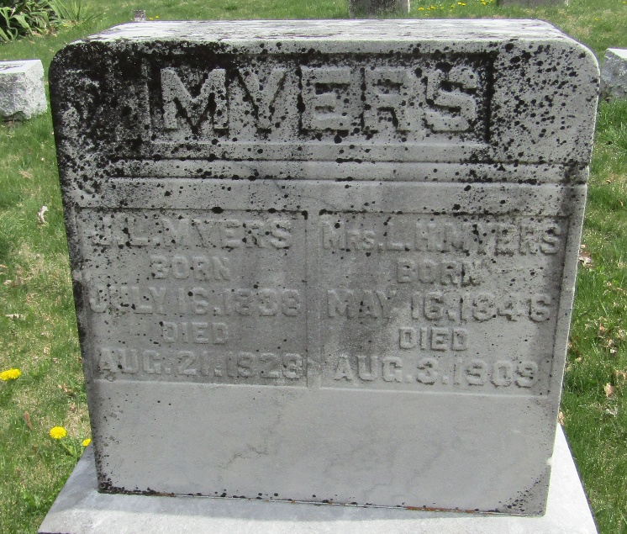

Luster Hellen Myers
Indiana, U.S., Death Certificates, 1899-2017
Name Lucretia Hellen Myers
[Lucretia Hellen Potter]
Gender Female
Race White
Marital Status Married
Age 63
Birth Date 16 May 1846
Birth Place Allen County, Indiana
Death Date 3 Aug 1909
Death Place Bluffton, Wells, Indiana, USA
Death Registration Date 1909
Father David Potter
Mother Rebeca Danelson
Informant J. L. Myers; Bluffton, Indiana
Burial August 5, 1909; Murray Cemetery

